Lesson Plan Title
Light and Color: Alma Thomas Inspired Painting

Grade Level
Pre K – 6th (lesson can easily be adapted to any age group)

Subject Area
Arts Integration Opportunities
Math: use sequenced patterns of numbers to make a ‘number circle’. In markers or pencils.
Spelling: use spelling words repeated as circles radiating from central point.
Science: look for evidence of symmetry in nature.

MSCCRS

Art Form
Visual Art

MSCCR Creative Arts Standards

21st Century Thinking Skills
Goal setting, creating, innovating, taking responsible risks, reflecting, observing, making connections, sequencing, predicting, comparing/contrasting, determining main idea, problem solving, cause and effect, evaluating.

MS Arts Learning Standards (based on 3rd grade)
VA:Cr2.2.3 a. Demonstrate an understanding of the safe and proficient use of materials, tools, and equipment for a variety of artistic processes.

VA:Cr2.1.3 a. Create personally satisfying artwork using a variety of artistic processes and materials
VA:Re7.2.3 a. Determine messages communicated by an image.
VA:Re9.1.3 a. Evaluate an artwork based on given criteria.

Duration
1 Hour

Materials
- 12”x12” white cardstock or heavy paper
- Tempera paint in primary and secondary colors
- Classroom set of size 7 round (not flat) paintbrushes, stamps, or stippling brushes
- Paint pallets (paper plates, or reusable plastic trays)
- Classroom set of water cups
- Images of Thomas’ paintings
- Scrap paper for practice
- Simple color wheel
- Paper towels to dab brushes

Subject Objectives

Art Objectives
Students will create a radially symmetrical balanced painting; view work and use painting techniques of Alma Thomas; use art vocabulary; use good craftsmanship when repeating brushstrokes.

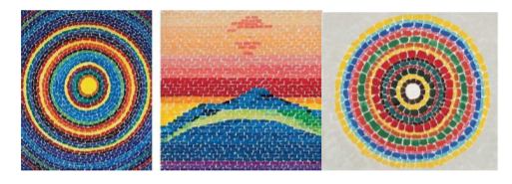

Arts Vocabulary
Color: the visible range of reflected light.
Primary colors: the basic colors from which all other colors are mixed: red, yellow, and blue; no other colors can be mixed to make primary colors.
Secondary Colors: created by mixing two primary colors: blue & yellow=green, blue & red= violet, and red & yellow= orange.
Shape: a two-dimensional (flat) area enclosed by a line. Shapes can be geometric (straight edges, often symmetrical) or organic (curved edges, asymmetrical).
Principles of Design
Balance: the way the elements are arranged so that individual parts appear equally distributed visually throughout the composition. i.e. spread out in a visually interesting way.
Radial Symmetry: a type of balance that is equally symmetrical from the center point throughout. All elements radiate from the center point.
Symmetrical/Formal Balance: exact appearance on opposite sides of a dividing line or plane.
Pattern: elements that repeat. In this lesson it is color and the shape of the brushstrokes.
Additional Vocabulary
Brushstroke: the shape the brush makes when it touches the surface.
Craftsmanship: neatness, control of tools. In this lesson it’s making careful, repeated brushstrokes.
Non-representational Art: a design not intended to be a picture of anything.
Representational Art: a picture of something, however simplified.

Lesson Description
Context (History and/or Artist)
"Man's highest aspirations come from nature. A world without color would seem dead. Color is life. Light is the mother of color. Light reveals to us the spirit and living soul of the world through colors."—Press Release, Columbus Museum of Arts and Sciences, 1982, for an exhibition entitled A Life in Art: Alma Thomas 1891–1978.
Alma Thomas retired from teaching art in 1960, after thirty-eight years in Washington, D.C. and she began to paint seriously. In the years that followed, she would come to be regarded as a major painter of the Washington Color Field School. This painting style involved using large fields of solid color. Alma Thomas used large repeated dabs of color, separated by white space in both representational and non-representational ways.

Discussion Points
- What does Alma Thomas’s work remind you of? (Small colored pebbles, small tiles/mosaics, colored glass, rainbows, etc.; there are no wrong answers.)
- What colors do you see in her work? (Primary & secondary.)
- Which paintings show symmetry? Which show radial symmetry?
- Which paintings are representational? Which are non-representational?

Instructions for Lesson
Before students arrive:
- Post vocabulary words and color wheel on the board.
- Pass out scratch paper and brushes for practicing brushstrokes on.
- Have the paint and water pre-poured in containers for table groups, don’t hand this out until after your discussion and demo.

- Go over vocabulary words. When talking about symmetry ask for visual examples in the classroom, from nature or from memory. Use the color wheel to remind them of primary and secondary colors. Don’t spend too much time on color. This should be a kind of review.
- Talk about Alma Thomas and show images of her work. Look for examples of symmetry, primary and secondary colors, and representational/non-representational compositions.
- Demonstrate dipping the brush in the paint, rolling it gently on its side to load it. Advise against ‘scooping’ paint with the brush, which may result in blobs on the paper. Any extra blobs on the brush can be removed with a paper towel.
- Demonstrate making different marks with the paint brush without spreading the brush out like a fan. “We use light to medium pressure, if we press too hard the brush fans out and can’t hold paint well.” As you demonstrate, have students copy with their dry brushes.
a) Dots – tip of brush
b) Medium dashes – medium pressure (no fans!)
c) Long dashes – medium pressure and drag the brush down longer
- Demonstrate washing your brush in the water, brushing it off on the edge of the container to get out the excess water and dabbing it on the paper towel to dry before changing colors. Have students copy this without paint and water.
- Hand out the paint, water, and paper towels.
- Have the students practice making the above 3 type of marks on the practice paper.
- Have everyone make a tiny dot or circle on their paper, it doesn’t have to be in the center.
- Demonstrate making a repeated brushstroke (short dash) around the circle as you turn the paper. Go slow and avoid smearing.
- Have students choose their best brushstroke to repeat around the circle. Go slow!
- When they finish a row, have them wash and dab dry the brush on the paper towel. Choose another color and make another dot type line around the last one. Demonstrate how close to start so as not to leave large white gaps between rows.
- Continue in this method until they have four or five rounds.
- Let them continue painting dotted or dashed circles and mixing colors, repeating colors if they like.
- As you circulate around the room, hold up examples of students who are using careful strokes and various choices of dots/lines.
- If time is running short, encourage students to make outer strokes larger.

Examples of student work:

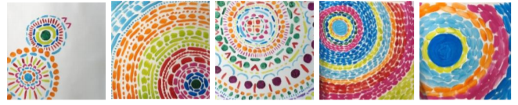

Recommended Resources
Artist Bio from Artsy website: https://www.artsy.net/artist/alma-thomas

Smithsonian American Art Museum: https://americanart.si.edu/artist/alma-thomas-4778

Drawing for Mindfulness video featuring similar project:
https://www.youtube.com/watch?v=OzN6onGTIOY&fbclid=IwAR33nufOxFOqWz6rhMJdHpwENYHrQ4A%20GjnSxbP2A63JBcIiX-U7a34Af6q4

https://www.bing.com/videos/search?q=alma+thomas+art&&view=detail&mid=761CC8B687AA3318D784761CC8B687AA3318D784&&FORM=VDRVSR

Additional Alma Thomas art lesson video:
http://isfdn.org/art-docent-lessons/2nd-grade/alma-thomas/
https://www.deepspacesparkle.com/alma-thomas-painting-a-rainbow/
Extended Learning Activities
Use stamps instead of dots.
Use colored rectangular or square paper ‘chips’ and glue in circles.
Radiate straight lines from a central point using a ruler.

Sources
http://isfdn.org/art-docent-lessons/2nd-grade/alma-thomas/
http://isfdn.org/core/files/isfdn/uploads/files/2_Symmetry_AlmaThomasFINAL.pdf

Tips
- Paint brush should be “washed and dabbed dry” between colors.
- Start this work from the center and work out, turning the paper as you go.
- Students slowly turn the work either clockwise or counterclockwise, depending on their handedness: for example, a right-handed student will turn it clockwise so as not to smear brushstrokes just painted.

Author
Adapted by Marsha Iverson

Additional Artifacts:
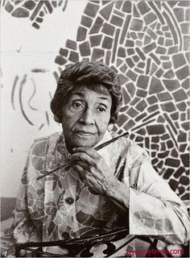

This art project is inspired by Alma Thomas. Thomas was an African American Expressionist painter and art educator. She is best known for her colorful abstract compositions.
As a child, Alma showed interest in art. She made puppets and sculptures at home and took her first art classes in high school. She earned her BS in Fine Arts in 1924.
She was the first graduate of her university’s Fine Arts program. Thomas continued her education and earned her master’s in art education from Colombia University in 1934.
She retired from teaching in 1960 and dedicated herself to painting.
Her style of painting included large abstract paintings filled with dense patterns of bright colors that almost mimic a mosaic pattern.
She created Color Field paintings in which the entire focus of the artwork is color and color theory.
Alma Thomas was an important role model for women, African American artists, and older artists (she was recognized for her paintings after her retirement from teaching). She was also the first African American woman to have a solo exhibition of her work at New York’s Whitney Museum of American Art.
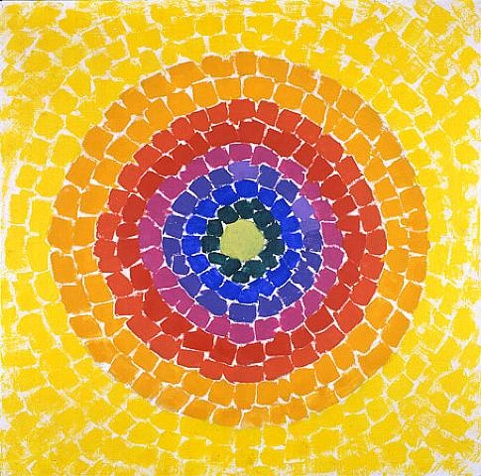

Resurrection by Alma Thomas is the color field painting inspiration for this art project.

Fun Fact: Alma Thomas’, Resurrection, was selected by Michelle Obama to hang in the White House Old Family Dining Room during Black History Month in 2015.

